

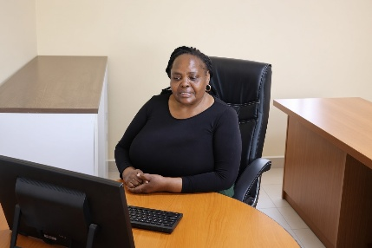
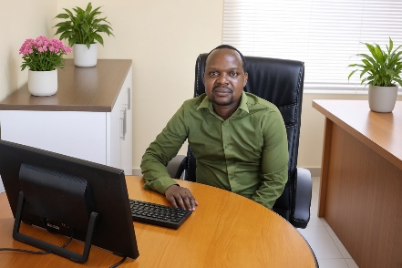
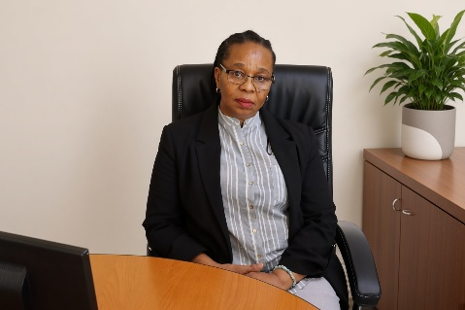



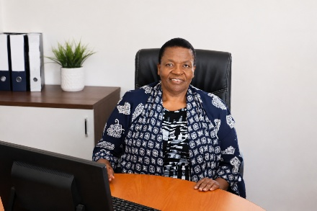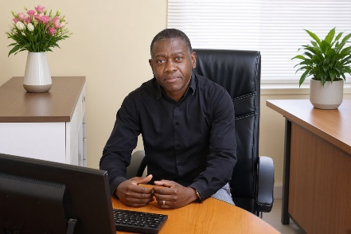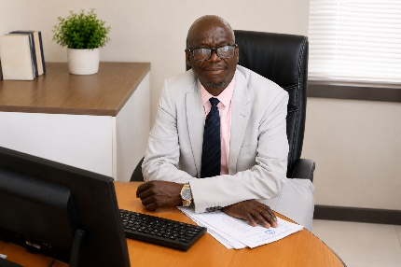
S. Fuyana
HOD – Intermediate Phase
Humanities

M. Moyo
Curriculum Manager
M. Munyikwa
HOD – High School
EMS & Technology
E. Mabulala
HOD – High School
Maths & Sciences
B. Blose
HOD – High School
Languages
M. Masuku
HOD – High School
English HL, Life Orientation & Religion Studies
M. Zengeya
HOD – High School
Humanities
N.P. Mnyamana
HOD – High School
Commercials
W. Moyo
Deputy Principal
Primary School
H. Kujinga
Deputy Principal
High School

M.T. Montjane
Principal

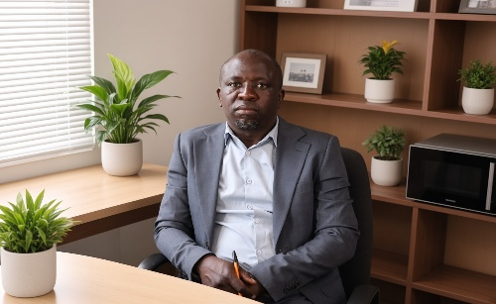

I.Bhunu
HOD – Intermediate Phase
Sciences



K. Morulane
HOD – Primary School
Afrikaans FAL
L. Mahwaya
HOD – Intermediate Phase
Maths


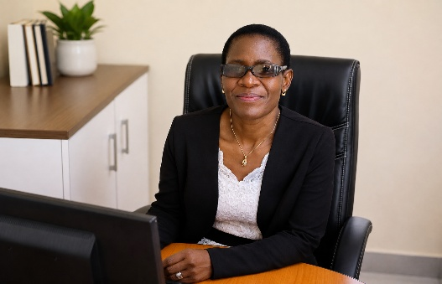

L. Moyo
HOD – Foundation Phase
L. Ndlovu
HOD – Foundation Phase

